Village of Monroeville

PRST ST

U.S. POSTAGE PAID

NORWALK, OH

PERMIT NO 104

21 N Main St

PO Box 156

Monroeville, OH 44847

ADDRESS SERVICE REQUESTED



COMMUNITY OPEN HOUSE

3 S. MAIN ST.

SUNDAY, APRIL 24, 2022

11AM – 4PM

FREE ADMISSION

www.facebook.com/Monroevillerailroadgroup/



ALL THE DETAILS COMING SOON!!!

Visit The Village Flea on Facebook.

The Administrative Offices

will be closed on the following

holidays…

May 30th – Memorial Day

June 20th – Juneteenth Day

July 4th – Independence Day

September 5th – Labor Day

October 10th – Columbus Day

The Huron River Joint Fireman’s Association will host their annual chicken BBQ on Sunday, April 24th at the fire station located at 155 Monroe St. This will be a drive thru carry out event beginning at 11:00am.

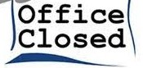

VILLAGE OF MONROEVILLE

COMMUNITY NEWSLETTER

**SPRING 2022**

Hello Friends and Neighbors,

Can you feel it? Days are getting longer. The temperature is getting warmer. Covid numbers are declining. I am pretty sure there is an overwhelming sense of relief and hope washing over all of us as we look to spring and its promise of new life. We are all excited about what is to come, but I also want to take time to recognize some exciting things we have recently experienced.

Over the past few months, there has been a plethora of amazing things happening in our Village, and especially to the people within our community. I am so proud and honored with our status of Monroeville being recognized as a Purple Heart Village. The wonderful ceremony was held in September, and you will find an article about the event inside this newsletter. As long as I am drawing attention to the contributions of our area veterans, I would like to congratulate our own Dick Palmer for being chosen as a Huron County Veteran of the Year! As usual, the veterans, especially through our American Legion Post 547, continue to be integral members of our community.

A Monroeville welcome is in order for our newest faces in the Village, Joe Galea, our new Council member and Kate Burns, the new Monroeville Public Library Director. You will find additional information about both of these people inside. In addition, I would like to officially welcome the new businesses in the Village since last year, Smash 180 and J & J Candles. Excitement is brewing as additional businesses are set to officially open later this year. Stay tuned!!! I would also like to highlight a few of our businesses for their tenure and dedication to our village. Pean’s Pizza celebrated 35 years of service this year. Also celebrating an anniversary year this year is Twist and Shout with fifteen years. (Allow me to personally thank Ken and Roschele Buraszeski of Twist and Shout for their generosity and recognition of our village employees. I know they appreciated your thoughtfulness!) Although it is different than a “business,” I also would like to recognize our Non-Food Bank that is sponsored by our Monroeville UCC for celebrating 15 years of servicing those in need within our community and surrounding areas! Well done!! Are there any other businesses or organizations celebrating milestones this year? Reach out and let me know. I would love to hear about them and let your good work be known!

A group of people who don’t get enough recognition for the wonderful work they do are our Village employees. There are about 25 knowledgeable employees that are one of the keys to the Village running smoothly. Many of these employees have a long-history of dedicated service, and I’d like to recognize them now. These milestones are as of this Spring:

With over 30 years of dedicated service: Bonnie Beck.

With over 20 years of dedicated service: Ann Beck, Dave Hamons, Dave Mahl and Don Clark.

With over 10 years of dedicated service: Troy Kimball, Rick Whiteside and Chief Gary Lyons.

With over 5 years of dedicated service: Dustin Crabtree, Jordan Eggleston, Tom Gray, Nick Meyer and Jordan Hanuscin.

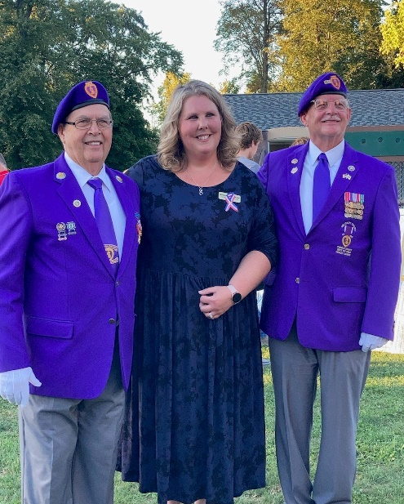There are two who recently have been with us 4 years, but before this, they have had many more years of dedication and need to be recognized: Bret Gfell and Wes Brewer.

Finally, I want to welcome the employees who have joined us in the last year: Neil Scheid, Kadon Martin, Isaiah Scheid and Colton Ott. Please take a moment to thank ALL of our employees and welcome our newest faces! We are lucky to have such a talented work force!

And finally, I would be remiss if I didn’t recognize a group of people who have brought this community together even more, and have given us all so much to be proud of. I am speaking about our students. Within the last year, “we” have experienced great success in academics, band, choir, arts, robotics, FFA, 4-H, athletics and many other areas. It is very exciting to watch our youth achieve! Our future is very bright, wouldn’t you agree!?!?!

Monroeville’s “*Little Village with a Gigantic Heart”* reputation continues to ring true. I am proud of everything that the Village has accomplished and will continue to strive for bigger and better things for our future!



Yours in Service,

Mayor Melissa Fries-Seip

 Pean’s Pizza

Celebrating its 35th Hello everyone! My name is Kate Burns

anniversary! and I am the new Director of Monroeville Public

Library. Before coming here, I worked as a

A great place to gather with friends and middle school library Media Specialist, and part-

family. Jeff has something for everyone with time as a Circulation Desk Librarian in the public

pizza, subs, salads, wings, and more! Be sure to library I grew up going to. I spend my free time

stop in and congratulate Jeff and his staff. And reading, knitting, hiking and teaching yoga!

while you’re at it, have a seat, relax and enjoy I want to thank everyone for welcoming me

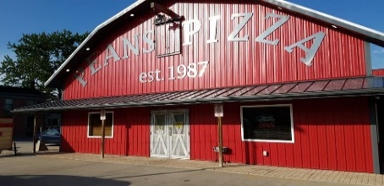a great meal. to town, I love it here! If you have not stopped

by the library, please do and introduce yourself!

We are adding new programs all the time, so be

on the lookout for our newsletter on our website’s

 front page. My biggest goal for the library is to

make it a community gathering place!

I hope to see all of you soon!

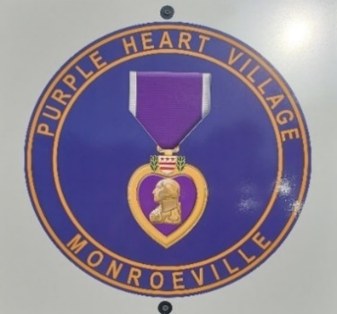The Village of Monroeville became an official Purple Heart Village on September 28th at a wonderful ceremony at Clark Park. This designation allowed the village to be a part of the Purple Heart Trail, which commemorates military men and women who have been killed or wounded while in combat. Purple Heart villages are known for their strong commitment to veterans and those who have received the Purple Heart.

The best of Monroeville’s dedication, patriotism and sense of community was on display that evening as we came together to recognize those eighteen individuals who have received this most prestigious medal. Individuals, businesses, and community groups contributed to the evening’s program, which saw local and state officials stopping by to participate and congratulate Monroeville on the honor. A dessert reception followed the program, which also included musical performances by the high school band and choir, a special presentation to the Purple Heart awardees, Honor Guard and Color Guard presentations by the American Legion Post 547, a bagpipe tribute and a wall of honor displaying the names, photos and other information Purple Heart families wanted to share. Monroeville now has signs at the village entryways showing our proud Purple Heart designation.

The Purple Heart medal is the oldest military decoration in present use and was established by General George Washington during the Revolutionary War on August 7, 1782. There are approximately 1.8 million recipients of this prestigious honor. National Purple Heart Day is recognized annually on August 7th.





Join us in welcoming Joe Galea to Village Council. Joe was elected to council in November. He is a recent transplant to the Village, moving here after getting engaged to his now-wife Alysha (Whitacre), a lifelong Monroeville resident. Joe has been an attorney at Murray & Murray Co. in Sandusky since 2014. While living in Sandusky, Joe was involved in the city's landmark and planning commissions. Joe ran for Council to be more involved in our close-knit community, and to continue his interests in planning and historical preservation. Feel free to contact Joe with your questions or concerns about the Village at any time by emailing him at [12FultonSt@gmail.com](mailto:12FultonSt@gmail.com)

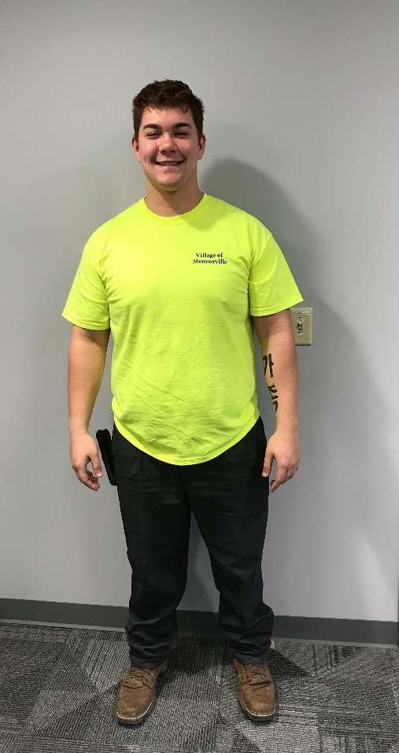The Water & Wastewater Divisions welcomes new employee, Isaiah Scheid. Isaiah is a 2021 graduate of Monroeville High School and is excited to work in the Village he grew up in.

We would like to remind all sanitary sewer users not to dispose of any mercury containing items or fluids into the sewer. There is a ”Mercury in the Household” brochure on the Villages website under the Departments tab for Wastewater. The annual mercury collection drive will be Monday May 2 through Sunday May 8, 2022. Please call before bringing your mercury in. (419) 465-4182.

The Wastewater Dept. will continue to clean and inspect sanitary sewer mains this spring.

Our annual Combined Sewer Overflow Report (CSO) can be viewed on the Village of Monroeville’s website under the Department’s dropdown tab, then click on Wastewater Department.

The following is a link to view the OEPA required Backflow informational brochure,

[PWS-02-003 brochure.pdf (ohio.gov)](https://epa.ohio.gov/static/Portals/28/documents/pws/PWS-02-003%20brochure.pdf#:~:text=Ohio%20Administrative%20Code%20Chapter%203745-95%20requires%20the%20public,of%20their%20water%20customers%E2%80%99%20property%20to%20evaluate%20hazards.) This link is also available on the Village of Monroeville’s website. Click on Water Department under the Departments tab.

**MAINS TO METERS**

R. A. Bores has completed the water main replacement on St Rt 20 from the intersection of St Rt 99 to the intersection of Hollister St and on Brown St. from Broad St to Hollister. The street and tree lawn restoration will take place this spring. Thank you for your understanding and patience during this project.

Along with water mains, you may have noticed Village crews working in and around your water meter pits. We have completed all pit style meter replacements in the Village and we are in the process of replacing all meters that are located inside homes and businesses. We will be calling the residents with meters inside to set up a time to replace these in home meters. We would like to thank you in advance for your cooperation and understanding.

Water & Wastewater Division

The Electric Department would like to welcome our newest employee/apprentice, Colton Ott. Colton joined our team on 3/14/22 and we welcome his enthusiasm and knowledge.

In the summer and winter months, there are several no-cost ways to save electricity, such as turning off unnecessary lights, unplugging unused electronics, avoid using electric heaters and set optimal air conditioner or heat temperatures.

Ohio’s peak season for tornadoes is April through July. Please remember that the Village tornado siren is meant to alert people who are outdoors so that they are able to seek shelter from an approaching storm.

Please report any electric outages or problems to the Electric Department (419-465-4149)as soon as possible. If the issue occurs after hours, please call the Monroeville Police Department and they will contact an on-call Electric Department employee. NEVER TOUCH any electric lines that are on the ground or within reach.

Electric Division

Save The Date! Hooked on Fishing is back!!



On May 30th immediately after the Memorial Day parade and ceremonies, the Monroeville Police Department will be hosting our annual Hooked on Fishing event. All are invited. Hamburgers, hot dogs, snacks, and soft drinks will be provided. Children ages twelve and under are invited to participate in the fishing contest. Safety Town will be conducted this summer, however no definite date has been set.



We continue to recruit for part time officers. However, like all other departments throughout the country, fewer and fewer people want to become police officers. We will continue our endeavors and attract qualified applicants.

Chief Lyons has been elected as second Vice Chair of the North Central Working Group of the U.S. Department of Justice. The Department of Justice has four working groups. Each group is comprised of 12-16 states. The mission of these working groups is to formulate policies and standards that will eventually be adopted by all criminal justice agencies throughout the United States. The North Central Group is comprised of Ohio, Indiana, Michigan, Illinois, Wisconsin, Missouri, North Dakota, South Dakota, Minnesota, Nebraska, Iowa, and Kansas. Each state has a local law enforcement representative and a state government representative. Chief Lyons is the law enforcement representative for Ohio.

Officer Nick Meyer recently graduated from North Central State College with an Associated Degree in Police Science. Officer Meyer excelled in his class and graduated with a 4.0 GPA. Congratulations Nick!!

We are in the final stages of becoming certified through the Ohio Collaborative. The Collaborative is a State of Ohio panel that has established recommended guidelines in areas of Use of Force, Recruitment, and Anti-Bias enforcement.

The Monroeville Police department received a grant award from the Ohio Department of Criminal Justices Services for the purchase of body cameras. The department currently utilizes recording cameras in the police cruisers. The addition of body cameras will add an extra layer of transparency. The grant award is $2,435 and covers the entire cost of the body cameras.

Lastly, because of a decision by the Ohio Supreme Court, everyone who wishes to contest the red light or speeding violation via photo enforcement, will be heard at the Norwalk Municipal Court.

Chief Gary Lyons and Staff



CTG (Control the Game), located at 15 Fort Monroe Industrial Parkway, is an indoor facility that includes a volleyball court, basketball hoops, fully netted turfed area, and batting cages for baseball and softball.

Aaron and Angie Kalizewski, owners of CTG, opened the indoor sports facility in January of 2021. Like many, the Norwalk couple saw their three grade-school aged children losing practices because of a lack of a venue and the inability to get inside of schools. And so CTG was born. The name “Control the Game” comes from a saying Angie has used often in her coaching. You start here, in the gym, and put the work in, which helps you control the outcome of the game.

This hidden gem boasts full sized cages that convert to baseball and softball, with the turfed area surrounded by netting all the way around the top, bottom and sides. This enables the players to live pitch and hit safely with multiple stations set up. There is also a full court for volleyball as well as basketball hoops. They also offer private lessons, group lessons, and youth clinics.

For more information, please visit their Facebook page (CTGSports) or email them at [ctgsports1@gmail.com](mailto:ctgsports1@gmail.com).

Submitted by Sue Rogers



Monroeville has once again been recognized as a Tree City for 2021. This will be the 15th year we have had that designation. We are planning an Arbor Day celebration for late April and the public is welcome.

**THE RIGHT TREE FOR THE RIGHT PLACE**

The Shade Tree Commission is in charge of the trees in the boulevard. We plant, recommend maintenance and removal for these trees. If you would have a concern or want a tree planted in your boulevard, please contact the Village Office and they will let us know. We are very cognizant in making sure the trees that are planted are in the right spot. Trees are a very important resource for our Village.

Shade Tree Commission





Yard waste has begun. A reminder to our residents within the Village corporation limits, yard waste includes grass clippings, hedge trimmings, cut up limbs and branches, leaves and other yard material. Contents and weight limits (40lbs) will be strictly enforced. Have your containers at curbside by 7:00am on the second and fourth Tuesday and not more than 48 hours prior to the scheduled pick-up date. If there are any questions about yard waste collection, please call the Street Department at 419-465-2800.





As the weather warms up and we begin to think about home improvements please take note that an application for zoning compliance must be approved before any structure can be built, altered, or added to. This includes fences, sheds, gazebos, pools, patios, decks, additions, signs, etc.



VILLAGE OF MONROEVILLE

21 N MAIN ST PO BOX 156

MONROEVILLE, OH 44847

MELISSA FRIES-SEIP, MAYOR

mayor@monroevilleohio.com

BONNIE BECK, FISCAL OFFICER

fiscalofficer@monroevilleohio.com

TOM GRAY, VILLAGE ADMINISTRATOR

villageadm@monroevilleohio.com

MONROEVILLE POLICE DEPARTMENT

NON-EMERGENCY 419-465-2474

ELECTRIC DEPARTMENT

monroelectric@monroevilleohio.com

STREET DEPARTMENT

streets@monroevilleohio.com

WATER/WASTEWATER DEPARTMENT

water@monroevilleohio.com



**BE ALERT! ACCIDENTS HURT**

With warm weather approaching, we would like to remind residents to pay a little more attention while driving. There will be a lot more children out playing, and spring also brings out bicycles, folks walking, and motorcycles.

Motorists tend to forget not seeing motorcycles out and about over the long winter, so a renewed “eye” while driving is necessary. Not being used to seeing cycles can cause drivers to pull out in front of them. The consequences can be disastrous.

Spring is also a good time for parents to check over kids’ bikes, scooters, skateboards, etc., to make sure they are ready for safe operation.

Have a fun and safe summer!





 **Growth is never by mere chance.**

**It is the result of forces working together.**

Many changes in the make-up of the downtown area have either taken place or are on the horizon.

J & J Candles has opened for business on Monroe Street. There is a wonderful inside filled with crafts, candles, and treasures.

Dave Luna has purchased the former Leis Furniture building next to the Legion. His tentative plans call for remodeling for a multiple-business use.

Caleb’s House of Hope has opened its doors in the former Metal’s for Mom’s location. This is an organization whose mission is to promote Anti-Bullying and make all of us more informed as to how to deal with and recognize any signs of bullying.

At 9 South Main, work will be starting on the opening of a new clothing store. Hannah Taylor and a partner are establishing this new business.

The Village Barn is preparing for a Grand Opening with expanded services and a totally new look.

The South Main Street water line, between US 20 and Norwalk Street is planned for replacement. Over the past couple of years, this line has suffered many leaks and breaks which impacted the reliability of water service in that area.

A connecting water line is planned between Hilltop Court and Great Lakes Truck. This line will run along back lots and will serve as a tie line from US 20 to the North Street area. With the completion of these projects, we will be winding down our water infrastructure replacements for the near term.

Once the weather does tend more towards spring, restoration work, along last fall’s US 20 water line replacement, will get underway. Grading, seeding, concrete and selected pavement replacement are on the agenda.

Street resurfacing is scheduled for Brown and for Hollister. The full length of Brown will be resurfaced with Hollister being resurfaced between Brown and US 20.

Council is keenly aware of the condition of Hamilton Street and other streets in the Village and is exploring ways to secure funding to support a pavement replacement.

The downtown merchants are contemplating moving the Village Flea to a September time slot. This event is a tremendous drawing card for the Village, and has enjoyed great success since its inaugural event.

If you have not yet checked it out, please take a look at Marsh Park. A revitalization is underway which includes expanded parking, improved ball fields, and upgrades to the tennis and basketball courts.

New cross walk flashers have been installed at Clark Park. ODOT performed this installation on behalf of the Village. The funding for this project came from the Governors’ Safety Grant program.

Lot sales are on the move and new home construction is underway at Eagle View. We are optimistic this pattern will continue and result in a very nice growth spurt for the Village.

Columbia Gas has announced a gas line replacement project on River Road from Hamilton Street to the Trans Canada regulator station north of Washington Street. This is the main line feeding all of the Village and is in critical need of repair. Work will also include the installation of new service lines on Horseshoe Dr. and Kreider Lane. This project is set to roll out in late Summer.

“*If you have ideas, you have the main asset you need, and there isn’t any limit to what you can do with your business and your life. Ideas are any man’s greatest asset.” Harvey Firestone*

Tom Gray, Village Administrator

REMINDER! The Village of Monroeville switched to RITA (Regional Income Tax Agency) for municipal income taxes effective 1/1/21. Please be sure to file your Village of Monroeville income tax return with RITA, at [www.ritaohio.com](http://www.ritaohio.com).

***\*\*\*INCOME TAX RETURNS ARE DUE BY MONDAY, 4/18/2022!\*\*\****

If you owe an income tax balance that accrued prior to 1/1/21, please contact the Village of Monroeville Administrative Office at 419-465-2922 to make payment arrangements.

Penalty and interest charges went into effect with all RITA invoices dated 1/21/22 and after, for late filing, balance due and estimated payments. RITA penalty and interest rates can be found on [www.RitaOhio.com](http://www.RitaOhio.com). State of Ohio Laws governing interest and penalties can be found at Ohio Revised Code Section 718.27.

We would like to take this opportunity to clarify and inform our utility customers of the process of utility billing, payment remittance and disconnections due to non-payment.

Monthly utility invoices are processed within the last few days of the preceding month in which they are due. All invoices are mailed via the Postal Service. Several years ago, the USPS made the decision to move bulk mailing away from smaller Post Offices to larger facilities. Our bulk mailings, which include utility invoices, newsletters and water consumer confidence reports, are now taken to the Norwalk Post Office, the first step in their journey. From there they are sent to the Cleveland mail distribution center for processing. They then return to the Norwalk Post Office and from there, to our local Post Office. Due to this multi-step process the date in which you receive your utility invoice can vary from month to month. We cannot guarantee you will receive your invoice by the 1st of the month. If at any time you have not received your invoice in a timely manner, please contact our office and we will can let you know the amount due.

As you look at your utility invoice you will see a “Net” amount and a “Gross” amount. If your payment is received by the 10th of the month, the “Net” amount is due. We do give a grace period of a day or two depending on whether or not the 10th of the month falls on the weekend. Please remember that after the grace period, the “Gross” amount of your invoice is due in order for your account to be satisfied. This gross amount includes a 10% late fee. If paying by check, please do not postdate your check. This action does not allow for posting of your payment to your account.

Disconnection notices are in the mail no later than the 20th of each month. There are times in which this notice and your payment may overlap each other. Therefore, if you receive a notice and you have paid your utility invoice, please contact our office to ensure your payment was received, and then disregard the notice. If you have not paid your invoice at the time disconnection notices are received, please note the date on the notice in which the bill must be paid. Payments made within 72 hours of disconnection must be made in the form of cash, money order, or credit/debit card. Checks will not be accepted. **Payment** **in full is required** for your account to be satisfied and to avoid disconnection. If a disconnection occurs, the total of your invoice and a reconnect fee will be required prior to 3:00pm for reconnection on the same day.

There are organizations that may be able to help you with your utility bill. This information is available at the Administrative Office. If you are going to seek assistance with your bill, please contact the organization as soon as possible as a few of them require an appointment.

As always, if you have any questions relating to your utility invoices, please contact our office at 419-465-2922 and we will be happy to assist you.

**PUBLIC NOTICE**

Utility customers are hereby notified that it is against the law to interfere or tamper with any equipment owned by the Village of Monroeville and/or Monroeville Utilities.